The Assimp library has been first installed, and then the scene which was given in class have been recreated using the Assimp library to produce the following:



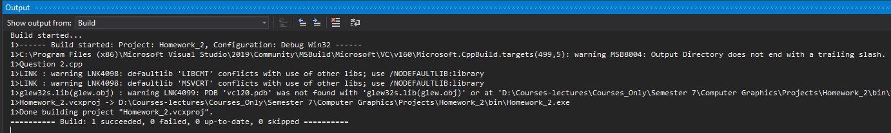

Models Citation: All model used, has been given in class except for the following

1. Model by Berk Gedik, from: <https://sketchfab.com/3d-models/survival-guitar-backpack-low-poly-799f8c4511f84fab8c3f12887f7e6b36>